**EV**

**Market Segmentation Report**

* ***Pragati Chauhan***

***09 July 2024***

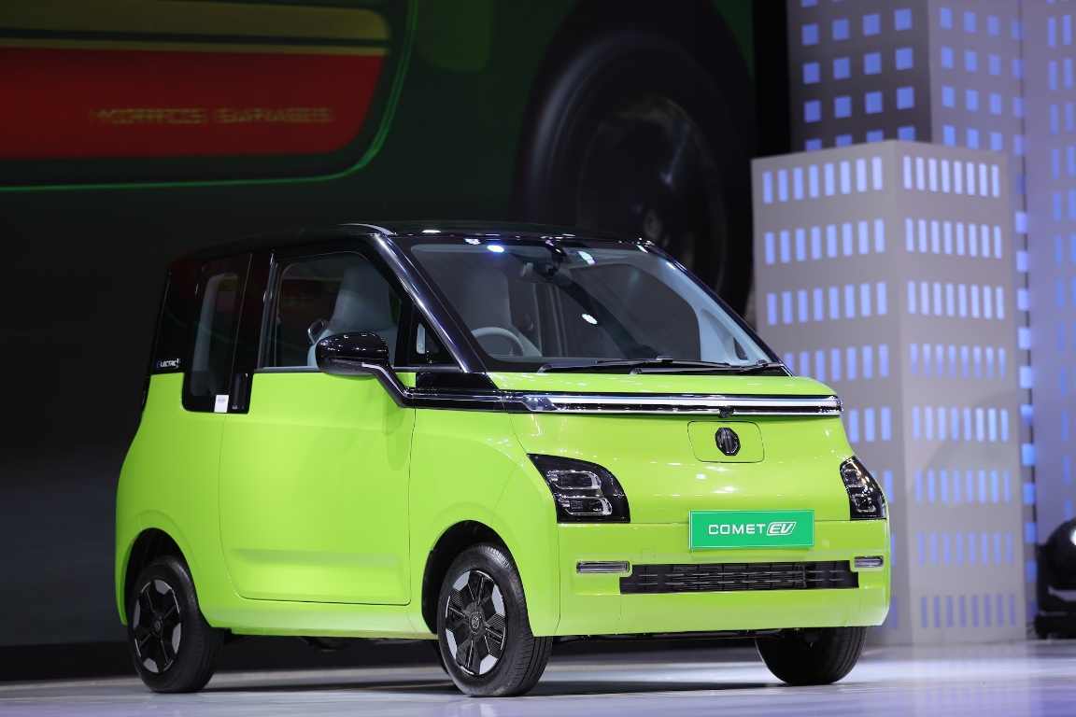

# **Comprehensive Analysis of India's Electric Vehicle Market**

# **Abstract**

This project presents an in-depth analysis of India's electric vehicle (EV) market, particularly focusing on segmentation derived from sales data, customer reviews, and technical specifications. The study emphasizes the robust growth of India's two-wheeler market, identifying it as a primary revenue source. Utilizing behavioral variables from customer reviews, a rigorous market segmentation analysis was conducted using the standard k-means algorithm. This analysis effectively divided the market into four distinct segments.

Segment 1 stands out, constituting 39% of the consumer base, representing a substantial market opportunity and serving as the optimal target for our venture. The analysis guides the recommendation of specific electric two-wheeler technical specifications tailored to meet the preferences of Segment 1 consumers. These specifications, coupled with a competitive price range, align closely with consumer preferences, ensuring affordability and competitiveness. This strategic alignment positions our venture optimally within India's EV landscape.

# **1.0 Introduction**

India is undergoing a significant shift in its transportation landscape, driven by the adoption of Electric Vehicles (EVs). Factors such as rapid urbanization, a growing population, and increased income levels have fueled the embrace of EVs as eco-friendly alternatives. Among these, electric two-wheelers have emerged as pioneers due to their affordability and wide acceptance. These vehicles are reshaping India's mobility narrative by offering a sustainable solution to pollution and greenhouse gas emissions.

The Indian government has supported this transition through policies that encourage local manufacturing and support a robust network of manufacturers, dealers, and service providers. By 2023, the electric two-wheeler market in India has symbolized the success of these efforts and the growing acceptance of clean mobility solutions. This study focuses on the electric vehicle industry, especially electric two-wheelers, combining behavioral segments, psychographic data, and vehicle specifications to provide informed EV price recommendations. This approach aims to empower consumers, policymakers, and industry stakeholders by understanding consumer behavior and preferences, illuminating the path toward a sustainable and consumer-centric electric transportation system in India.

# **2.0 Problem Statement and Fermi Estimation**

### 2.1 Problem Statement

The challenge is to strategically position our Electric Vehicle Startup in the Indian market by utilizing data-driven insights derived from sales data, customer reviews (encompassing behavioral and psychographic data), and technical specifications of electric vehicles. Our objective is to employ these insights to effectively segment the market and recommend target segments for our electric vehicles.

#### **2.2 Fermi Estimation**

1. **Data Collection and Assessment**
   * Gather sales data, EV customer reviews, and technical specifications.
   * Evaluate the reliability and comprehensiveness of the collected data.
2. **Segmentation Using Behavioral Variables**
   * Utilize behavioral data to identify patterns and segments within the customer base.
   * Estimate the size and characteristics of each segment using data-driven techniques.
3. **Analysis of Psychographic Data**
   * Analyze psychographic data within each behavioral segment to discern customer preferences and motivations.
   * Estimate the psychographic traits and preferences of customers within each segment.
4. **Technical Specification and Price Analysis**
   * Evaluate technical specifications of electric vehicles within identified segments.
   * Estimate the impact of technical features on customer preferences and purchasing decisions.
5. **Target Segment Selection**
   * Select target segments based on a thorough analysis of behavioral, psychographic, and technical factors.
6. **Customization of Marketing Mix**
   * Develop a customized marketing mix tailored specifically for the selected target segments.
   * Estimate the effectiveness of various marketing strategies within the selected target segments, aligning them with customer preferences.
7. **Segment Recommendation**
   * Combine segment analysis results and marketing mix customization findings to finalize segment recommendations.
   * Recommend target segments with the highest estimated market potential, ensuring a focused and targeted market entry strategy.

# **3.0 Data Sources and Collection**

For this project, data was gathered from three sources:

1. **Sales Data:** Obtained from the Society of Manufacturers of Electric Vehicles, spanning 2017 to 2023, covering sales figures of electric two-wheelers, three-wheelers, four-wheelers, and buses.
2. **Customer Reviews:** Extracted from bikewale.com, comprising electric two-wheeler customer reviews.
3. **Technical Specifications:** Also, from bikewale.com, presenting detailed technical specifications and pricing information of electric two-wheelers.

By integrating these datasets, a robust understanding of the electric vehicle market was developed, ensuring a data-driven, market-relevant segmentation approach.

# **4.0 Data Pre-processing**

The data pre-processing phase involved:

* **Data Consolidation:** Using pandas to merge data sheets into a unified dataset.
* **Data Accuracy:** Ensuring the accuracy of EV maker names.
* **Data Aggregation:** Aggregating electric two-wheeler sales data to understand market trends.
* **Data Preparation for Market Segmentation:** Merging customer reviews with vehicle technical specifications, handling null values logically.
* **Sentiment Analysis:** Conducting sentiment analysis using nltk on customer reviews to gain qualitative insights.
* **Behavioral Variable Preparation:** Isolating and preparing variables like Visual Appeal, Reliability, Performance, Service Experience, Extra Features, Comfort, Maintenance Cost, and Value for Money for market segmentation analysis.

# **5.0 Segment Extraction**

#### **5.1 Using Sales Data**

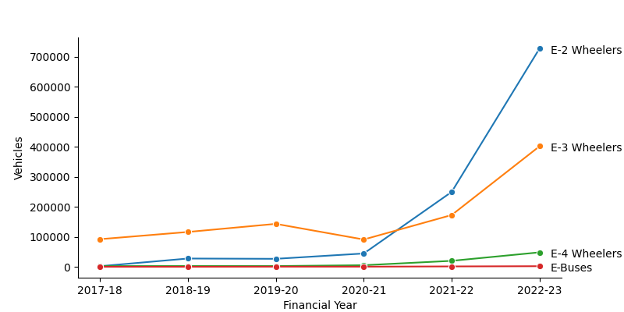

***Figure 5.1 India’s Electric Vehicle Market***

* **Growth Trajectory:** Analysis showed the remarkable growth of India's two-wheeler market in 2023 (Figure 5.1).

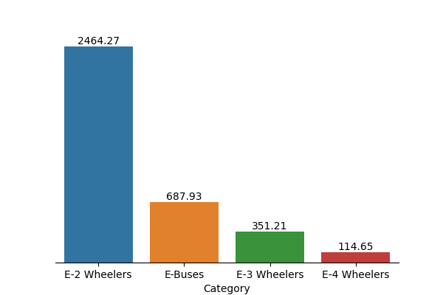

***Figure 5.2 India’s electric vehicle industry in crores***

* **Market Value:** Highlighted the economic significance of two-wheelers (Figure 5.2).

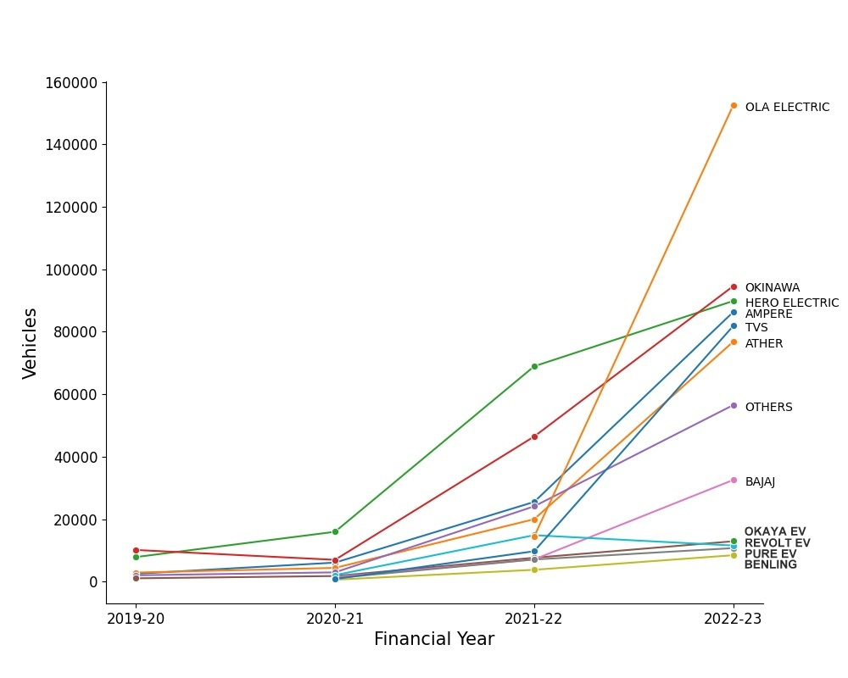***Figure 5.3 Top electric two-wheeler companies***

* **Market Leaders:** Identified Ola Electric as the market leader in 2023 (Figure 5.3).

#### **5.2 Using k-Means**

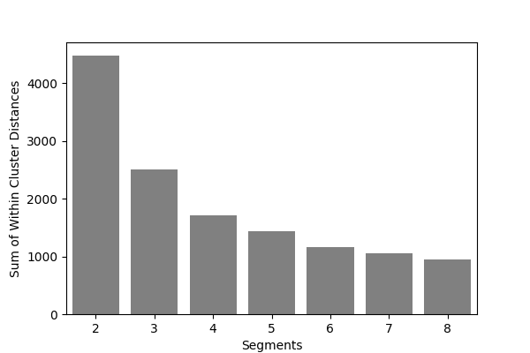

***Figure 5.4 Scree plot for the electric vehicle data set***

Applying the k-means algorithm revealed four optimal market segments, as indicated by the scree plot (Figure 5.4).

### 6.0 Profiling and Describing Segments

#### **6.1 Profiling Segments**

Segment analysis identified four distinct consumer segments:

* **Segment 0:** Values visual appeal, reliability, performance, service experience, and comfort (15% of consumers).
* **Segment 1:** Dissatisfied across all aspects, making it the largest but least satisfied group (39% of consumers).
* **Segment 2:** Values visual appeal, reliability, service experience, comfort, and value for money (33% of consumers).
* **Segment 3:** Values visual appeal, reliability, performance, service experience, extra features, and maintenance cost (13% of consumers).

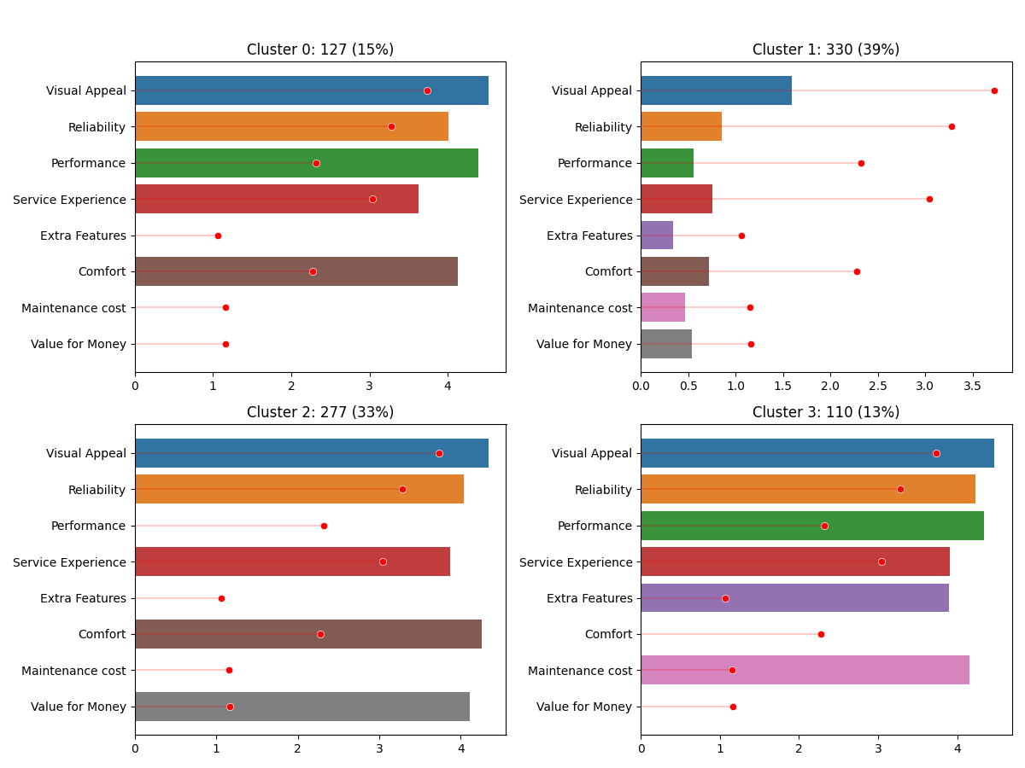

***Figure 6.1 Segment profile plot for the four-segment solution***

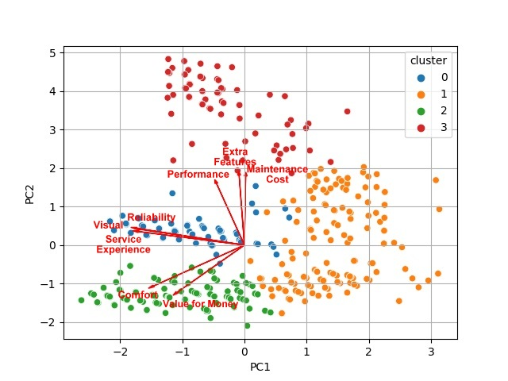

***Figure 6.2 Segment separation plot using principal components 1 and 2***

#### **6.2 Describing Segments**

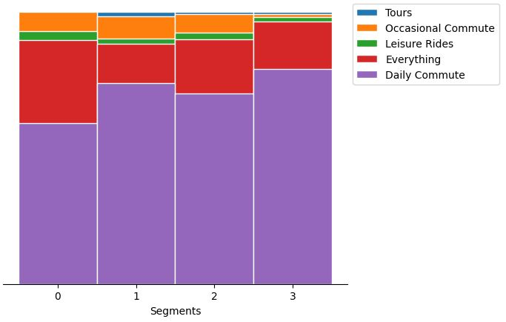

***Figure 6.3 Mosaic plot showcasing electric vehicle usage patterns across segments***

**Segments**

* **Usage Patterns (Figure 6.3):** Predominantly used for daily commuting.

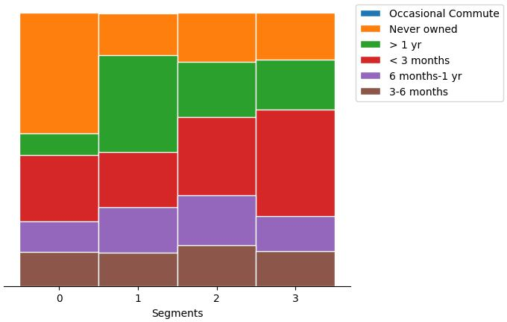

***Figure 6.4 Mosaic plot depicting the ownership duration of electric vehicles across***

* **Ownership Duration (Figure 6.4):** Segment 1 owns EVs for over a year, Segment 0 has no prior ownership experience.

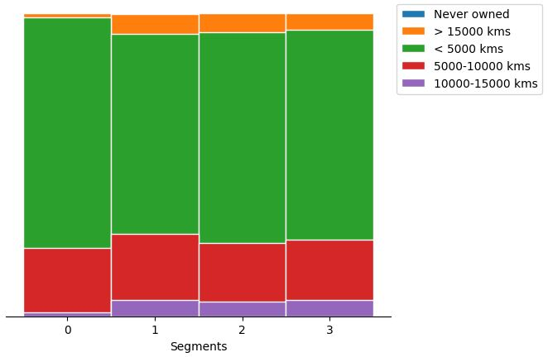

***Figure 6.5 Mosaic plot outlining consumers distance covered by consumers on electric vehicles***

* **Distance Covered (Figure 6.5):** Most segments cover distances below 5000 km.

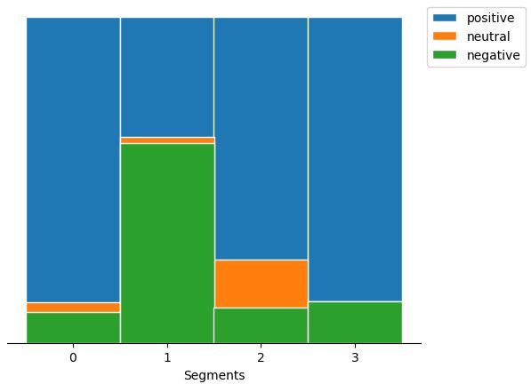

***Figure 6.6 Mosaic plot displaying consumer sentiments toward electric vehicles***

* **Consumer Sentiments (Figure 6.6):** All segments, except Segment 1, exhibit positive sentiments.

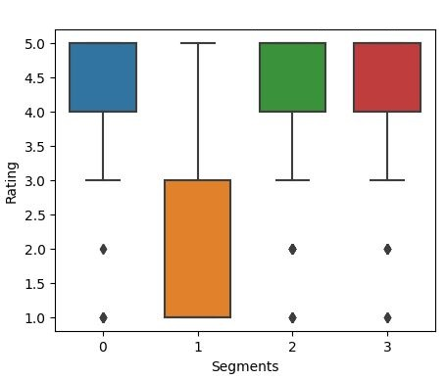

***Figure 6.7 Parallel box-and-whisker plot showcasing consumer ratings across segments***

* **Consumer Ratings (Figure 6.7):** Significant differences in average ratings among segments, with Segment 1 being the least satisfied.
* In analyzing the technical specifications of electric vehicles across different segments, distinct patterns emerge. Segment 0 features a higher price range, highlighting a preference for premium electric vehicles within this group, as shown in **Figure 6.8** (a), a parallel box and whisker plot representing the price range. Conversely, Segment 1 has a lower price range, indicating a focus on more budget-friendly options. Segment 2 and Segment 3 also emphasize affordability, albeit with slight variations. These findings reflect consumer preferences, revealing varied economic considerations within the market.
* Regarding riding range, Segment 0 stands out with a higher average range, suggesting a preference for electric vehicles with extended ranges, as depicted in Figure 6.8 (b). In contrast, Segment 1 and Segment 2 focus on moderate ranges suitable for daily commuting. Segment 3 falls in between, catering to consumers desiring slightly longer distances, highlighting nuanced commuting needs.
* When considering top speed, Segment 0 and Segment 3 opt for vehicles with higher speeds, while Segment 1 and Segment 2 prioritize lower speeds suitable for city commuting. These trends are illustrated in Figure 6.8 (c).
* Weight plays a crucial role, with Segment 0 and Segment 1 favoring slightly heavier vehicles, as shown in Figure 6.8 (d). Segment 2 and Segment 3 lean towards lighter options, accommodating diverse user preferences for vehicle weight.
* Lastly, battery charging time shows a significant difference. Segment 0 and Segment 3 prefer slightly longer charging durations, depicted in Figure 6.8 (e), emphasizing the convenience of overnight charging. Segment 1 and Segment 2 prioritize faster charging, catering to users seeking quicker turnaround times for their electric vehicles.
* These technical specifications, visually represented in the respective figures, underscore the nuanced preferences and priorities of each segment, shaping the landscape of the electric vehicle market in India.

|  |  |
| --- | --- |
| (a) | (b) |
| (c) | (d) |
| (e) | (f) |

***Figure 6.8. Parallel box-and-whisker plot of technical specification of electric vehicle by segment***

# **7.0 Selection of Target Segment**

Segments 1 and 2 were identified as potential focal points. Segment 1 (39% of consumers) offers a vast market base with diverse preferences, while Segment 2 (33% of consumers) values visual appeal, reliability, service experience, and comfort. By addressing Segment 1's dissatisfaction and enhancing Segment 2's positive perceptions, our strategy can yield significant results.

# **8.0 Customizing the Marketing Mix**

A customized marketing mix includes:

* **Product Customization:** Enhancing features to address dissatisfaction and emphasize value for money.
* **Price Customization:** Setting competitive and flexible pricing structures.
* **Promotion Customization:** Targeted advertising focusing on segment-specific preferences.
* **Place Customization:** Accessible distribution channels and a strong online presence.
* **People and Process Customization:** Training customer service representatives and streamlining processes.

# **9.0 Potential Early Market Customer Base**

Segments 1 and 2 represent the potential early market customer base. The target price for Segment 1 is between ₹51,094 and ₹1,67,844, while for Segment 2, it is ₹51,094 to ₹1,37,890. Segment 1, with a larger market share, is the primary focus for early market penetration.

# **10.0 Most Optimal Market Segments**

Segment 1, representing 39% of consumers, is identified as the most promising market segment. The recommended technical specifications are:

* **Price:** ₹70,688 – ₹1,29,063
* **Riding Range:** 89 - 180 km
* **Top Speed:** 58 - 116 kmph
* **Weight:** 76 - 120 kg
* **Battery Charging Time:** 3 - 5 hours
* **Rated Power:** 1200 - 5500 W

# **11.0 Conclusion**

Our analysis identifies Segment 1 as the optimal target, representing a significant market opportunity with 39% of the consumer base. By tailoring our electric two-wheeler specifications to meet the preferences of this segment, we ensure our products align with the demands of a large customer base. This strategic decision, grounded in market segmentation, consumer behavior, and technical specifications, provides a clear direction for market entry and sustained growth.

# **References**

1. Society of Manufacturers of Electric Vehicles, (2023, October), [SMEV](https://www.smev.in/ev-industry)
2. Bikewale, (2023, October), [Bikewale](https://www.bikewale.com/)
3. Dolnicar, S., Grun, B., & Leisch, F. (2018). Market Segmentation Analysis, Springer Open